**Capstone Project 1 Proposal**: **Supplier Pricing Prediction**

**Project Scope:**

Caterpillar (construction equipment manufacturer) relies on a variety of suppliers to manufacture tube assemblies for their equipment. These assemblies are required in their equipment to lift, load and transport heavy construction loads. We are provided with detailed tube, component, and annual volume datasets. Our goal is to build and train a model that can predict how much a supplier will quote for a given tube assembly based on given supplier pricing.

**Project Intution:**

Each supplier has their unqiue pricing model. Tubes can vary across a number of dimensions, including base materials, number of bends, bend radius, bolt patterns, and end types. From buyer’s perspective, altering any of these specs that are lower cost, requires fewer assembly steps and meets business requirements, will result in total lower cost.

**Model Evaluation**:

This will be based on RMSE error. Lowest RMSE would reduce the gap between Predicted and Actual pricing, which is preferred.

**Dataset Availability and Description:**

* Combine characterstics of each tube assembly with Supplier Pricing Dynamics to forecast Quote Price
* Price can be quoted in 2 ways
  + Bracket pricing: Purchase based on Quantity of tubes purchased
  + Non-Bracket Pricing: Purcahse based on minimum_order Quantity.
* Each Quote has annual usage (how many tube assemblies will be purchased in a given year)

**What does Dataset Contains?**

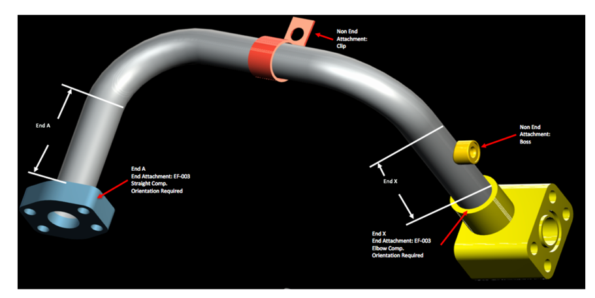

**Dataset Schema: Possible column joins based on common ID’s and component’s description:**

|  |  |
| --- | --- |
| **Dataset Tables** | **Content Headers and Description** |
| **Tube.csv** | |  |  |  |  |  |  |  |  |  |  |  |  |  |  |  |  | | --- | --- | --- | --- | --- | --- | --- | --- | --- | --- | --- | --- | --- | --- | --- | --- | | **tube_assembly_id** | material_id | diameter | wall | length | num_bends | bend_radius | end_a_1x | end_a_2x | end_x_1x | end_x_2x | end_a | end_x | num_boss | num_bracket | other |   **Description:**  -Available Tube Assembly Models or Id’s  -Type of material used  -end_a_1x and end_a_2x means if end is 1times or 2 times less trhan tube diameter.  -end_ a and end_x means type of end connection  -Bosses, brackets, other cutom features that can be attached permanently to the tube assembly. |
| **Bill of Material** | |  |  |  |  |  |  |  |  |  |  |  |  |  |  |  |  | | --- | --- | --- | --- | --- | --- | --- | --- | --- | --- | --- | --- | --- | --- | --- | --- | | **tube_assembly_id** | | component_id_1 | | quantity_1 | | component_id_2 | | quantity_2 | | component_id_3 | | quantity_3 | component_id_4 | quantity_4 | component_id_5 | | quantity_5 | component_id_6 | | quantity_6 | | component_id_7 | | quantity_7 | | component_id_8 | | quantity_8 | |   **Description:**  -List of components used in each tube assembly.  - Quantities used on each tube assembly |
| **Specs.csv** | |  |  |  |  |  |  |  |  |  |  |  | | --- | --- | --- | --- | --- | --- | --- | --- | --- | --- | --- | | **tube_assembly_id** | spec1 | spec2 | spec3 | spec4 | spec5 | spec6 | spec7 | spec8 | spec9 | spec10 |   **Description:**  -list of unique specifications for each tube assembly  -Used for reference to materials, processes and rust protection etc. |
| **Tube end form.csv** | |  |  | | --- | --- | | **end_form_id** | forming |   **Description:**  -end types physically formed only using wall thickness. Yes or No? |
| **Components.csv** | |  |  |  | | --- | --- | --- | | **component_id** | name | component_type_id |   **Description:**  -list of all components, name and category |
| **Comp_[type].csv** | **Adopter**   |  |  |  |  |  |  |  |  |  |  |  |  |  |  |  |  |  | | --- | --- | --- | --- | --- | --- | --- | --- | --- | --- | --- | --- | --- | --- | --- | --- | --- | | **component_id** | | component_type_id | | | adaptor_angle | | overall_length | | | end_form_id_1 | | connection_type_id_1 | | length_1 | thread_size_1 | thread_pitch_1 | | nominal_size_1 | | end_form_id_2 | | connection_type_id_2 | | | | length_2 | thread_size_2 | | thread_pitch_2 | | nominal_size_2 | | | hex_size | unique_feature | | orientation | | weight |   **Boss**   |  |  |  |  |  |  |  |  |  |  |  |  |  | | --- | --- | --- | --- | --- | --- | --- | --- | --- | --- | --- | --- | --- | | **component_id** | component_type_id | | type | connection_type_id | | outside_shape | | base_type | height_over_tube | bolt_pattern_long | bolt_pattern_wide | groove | | base_diameter | shoulder_diameter | unique_feature | | | orientation | weight |   **Elbow**   |  |  |  |  |  |  |  |  |  |  |  |  |  |  | | --- | --- | --- | --- | --- | --- | --- | --- | --- | --- | --- | --- | --- | --- | | **component_id** | component_type_id | | bolt_pattern_long | | bolt_pattern_wide | | extension_length | | overall_length | thickness | drop_length | elbow_angle | mj_class_code | | mj_plug_class_code | | plug_diameter | groove | unique_feature | | orientation | weight |   **Float**   |  |  |  |  |  |  |  | | --- | --- | --- | --- | --- | --- | --- | | **component_id** | component_type_id | bolt_pattern_long | bolt_pattern_wide | thickness | orientation | weight |   **HFL**   |  |  |  |  |  |  |  |  |  | | --- | --- | --- | --- | --- | --- | --- | --- | --- | | **component_id** | component_type_id | hose_diameter | corresponding_shell | coupling_class | material | plating | orientation | weight |   **Nut**   |  |  |  |  |  |  |  |  |  |  |  | | --- | --- | --- | --- | --- | --- | --- | --- | --- | --- | --- | | **component_id** | component_type_id | hex_nut_size | seat_angle | length | thread_size | thread_pitch | diameter | blind_hole | orientation | weight |   **Other**   |  |  |  | | --- | --- | --- | | **component_id** | part_name | weight |   **Sleeve**   |  |  |  |  |  |  |  |  |  |  | | --- | --- | --- | --- | --- | --- | --- | --- | --- | --- | | **component_id** | component_type_id | connection_type_id | length | intended_nut_thread | intended_nut_pitch | unique_feature | plating | orientation | weight |   **Straight**   |  |  |  |  |  |  |  |  |  |  |  |  | | --- | --- | --- | --- | --- | --- | --- | --- | --- | --- | --- | --- | | **component_id** | component_type_id | bolt_pattern_long | bolt_pattern_wide | head_diameter | overall_length | thickness | mj_class_code | groove | unique_feature | orientation | weight |   **Tee**   |  |  |  |  |  |  |  |  |  |  |  |  |  |  | | --- | --- | --- | --- | --- | --- | --- | --- | --- | --- | --- | --- | --- | --- | | **component_id** | component_type_id | bolt_pattern_long | bolt_pattern_wide | extension_length | overall_length | thickness | drop_length | mj_class_code | mj_plug_class_code | groove | unique_feature | orientation | weight |   **Threaded**   |  |  |  |  |  |  |  |  |  |  |  |  |  |  |  |  |  |  |  |  |  |  |  |  |  |  |  |  |  |  |  | | --- | --- | --- | --- | --- | --- | --- | --- | --- | --- | --- | --- | --- | --- | --- | --- | --- | --- | --- | --- | --- | --- | --- | --- | --- | --- | --- | --- | --- | --- | --- | | **component_id** | | component_type_id | | | | adaptor_angle | | overall_length | | | hex_size | | | end_form_id_1 | | connection_type_id_1 | | | | length_1 | thread_size_1 | | thread_pitch_1 | | nominal_size_1 | | end_form_id_2 | | connection_type_id_2 | | | length_2 | thread_size_2 | | | thread_pitch_2 | | | nominal_size_2 | | | end_form_id_3 | | | connection_type_id_3 | | | | | length_3 | thread_size_3 | | | thread_pitch_3 | | nominal_size_3 | | end_form_id_4 | | connection_type_id_4 | | length_4 | | thread_size_4 | | | thread_pitch_4 | | nominal_size_4 | | | | unique_feature | | | orientation | | | weight | |   **Description:**  -Information about each component used in the tube assembly |
| **Type_[type].csv** | **Component**   |  |  | | --- | --- | | **component_type_id** | name |   **Connection**   |  |  | | --- | --- | | **connection_type_id** | name |   **End**   |  |  | | --- | --- | | **end_form_id** | name |   **Description:**  Name of each category type used in components |
| **Train.csv** | |  |  |  |  |  |  |  |  | | --- | --- | --- | --- | --- | --- | --- | --- | | **tube_assembly_id** | supplier | quote_date | annual_usage | min_order_quantity | bracket_pricing | quantity | cost |   **Description:**  -train rows: 30,213  -total rows: 60,448  Train Split: 49.9% |
| **Test.csv** | |  |  |  |  |  |  |  |  | | --- | --- | --- | --- | --- | --- | --- | --- | | **id** | tube_assembly_id | supplier | quote_date | annual_usage | min_order_quantity | bracket_pricing | quantity |   **Description:**  -test rows : 30,235  Total wors: 60,448  Test Split: 50% |
| **Submission Sample.csv** | |  |  | | --- | --- | | **id** | cost | |

**Primary Join: Tube Assembly ID; Secondary Join: Component ID**

**Join Summary Table:**

|  |  |
| --- | --- |
| **Datset tables** | **Common Keys** |
| Connect Tube with Specs | Use Material ID with Specs. This has common material ID’d. |
| Connect Tube with bill of material | Use common Tube assembly ID |
| Connect Bill of material with components, component types, types of (component, connection and end), and tube end form | Use Common ID’d (Components ID, Component Type ID, end form ID, connection type ID) |
| Connect combined features with train table.  Train and Evlaute Table | Use common tube assembly ID |
| Use trained model to predict cost using Test dataset. | Use common tube Assembly ID |

**Challenge: How to connect all 21 tables in a way that we can draw insights?**

**Example:** Tube Assembly ID (Primary Join) is not directly linked to Component ID (Secondary join).

It is connected to multiple Component ID’s (1 to 8) in BOM table, which has to be linked to 11 other component tables.

**Why linking tables important?**

* Need to identify how selection of features such as use of certain material type, number of components in the tube assembly, volume etc will predict supplier pricing.
* Lower the difference between predicted pricing and given pricing in terms of RMSE, better should be the model predictability.

**Other Ideas:**

* Use external web sources such as industrial price index to understand material pricing trends. This will help us explore impact of material cost on the overall pricing.
* Segment suppliers based on order date, (volume or frequency of buy), built type and predicted cost. This will help us formulate appropriate startegy for sourcing tube assemblies

Example there would be 4 main categories:

* + - Tier 1: complex built, purchased often, high cost or large volume
    - Tier 2: lack supply, only few suppliers.
    - Tier 3: simple built, many suppliers
    - Tier 4: on spot buy, low cost or low volume

* Compare model prediction with deep learning model. This will allow us to evaluate how neural assigned weights can further learn from each features and if it will provide better prediction.

--------------------------------End--------------------------------